Iron supplementation does not significantly alter gut microbiome diversity or function in 12-month old anemic infants, but increases hemoglobin and ferritin levels
Aidan Chance, Jacqueline Chan, Bianca Hufana, Tiffany Huang, Rajbir Sidhu

Department of Microbiology and Immunology, University of British Columbia, Vancouver, British Columbia, Canada

Abstract
Anemia is a health condition that occurs when the levels of healthy red blood cells (RBCs) or hemoglobin are deficient. This affects oxygen transport throughout the body, resulting in negative cognitive, physiological and behavioural effects. Iron supplementation, such as ferrous sulfate (FeSO₄) and multiple micronutrient powders (MNP), is a common treatment for anemia by replenishing iron stores and normalizing hemoglobin levels. However, there is limited information on how FeSO₄ and MNP affect microbial composition in comparison to each other. In this study, we analyzed the influence of different iron supplementation types on gut microbiome composition and the effects of these microbial differences on hemoglobin and ferritin levels in 12-month-old anemic infants. We hypothesized that iron supplementation would lead to measurable shifts in both the composition and functional potential of the infant gut microbiome. We used 16S rRNA sequencing data to compare diversity metrics, differential abundance, predictive functional analyses, and linear regression. We found no significant differences in gut microbiome composition among 12-month-old anemic infants receiving different supplementation types. In addition, iron supplementation was found to be beneficial as increased hemoglobin and ferritin levels are associated with gut microbial diversity. Our study provided valuable insights into the effects of iron supplementation on the gut microbiome and the role microbial differences play in hemoglobin and ferritin levels. These insights have significant implications for selecting the type of iron supplementation to improve the health of anemic infants.

Introduction

Anemia is a health condition that occurs when there is a deficiency of healthy red blood cells or hemoglobin. Red blood cells (RBCs) transport oxygen from the lungs to tissues throughout the body, while hemoglobin is an iron-rich protein within RBCs that binds to oxygen and enables its transport through the bloodstream (1). Therefore, in anemic patients whose RBC or hemoglobin is deficient, blood has reduced oxygen delivery throughout the body (2). This lack of oxygen contributes to symptoms such as fatigue, weakness, and impaired cognition that many anemic patients experience (3).
Anemia can occur due to various reasons, including low birth weight or vitamin deficiency, but iron-deficiency anemia (IDA) is the most common form (4). Infants are especially vulnerable to anemia because of their rapid growth and increased nutritional requirements during early development. Iron deficiency is therefore a major contributor to anemia during infancy because iron is an essential nutrient for hemoglobin production and the formation of red blood cells (5).
If left untreated, anemic children may develop mental or motor development issues (2). Consequently, supplements such as ferrous sulphate (FeSO₄) or micronutrient powders (MNPs) are often recommended to infants to help increase iron levels (4). FeSO₄ is a synthetic agent used to provide iron to restore low iron levels, while MNPs are micronutrient powders containing vitamins and minerals such as vitamin A and iron that can be ingested (6, 7). Previous research has been done to observe the relationship between anemia and microbial diversity in infants, and it was found that there are no structural or functional differences in their microbiome compared to healthy infants (4, 8). However, when taking iron supplementation, infant gut microbial composition does become altered, such as reductions in Bifidobacteria and Lactobacilli, both of which are beneficial bacteria (9, 10).
Although both MNP and FeSO₄ are common types of supplements used to treat anemic patients, their effect on microbial composition relative to each other is not known. Furthermore, although many studies were previously done to observe the change in ferritin and hemoglobin levels after using FeSO₄ supplementation, little research has been done on MNP supplements.
This knowledge gap is essential because although FeSO₄ raises ferritin and hemoglobin levels, FeSO₄ is not always ideal because it reduces beneficial bacteria and can cause side effects like nausea and fever due to its higher iron dosage compared to MNP (11). Understanding how different iron supplementation strategies influence the gut microbiome may help identify interventions that improve infant iron status while minimizing disruptions to beneficial microbial communities.
To investigate this knowledge gap, the 16S rRNA sequencing data from McClorry et al. was used to analyze iron supplementation type (MNP vs. FeSO₄ vs. none) influences gut microbiome composition and how these microbial differences relate to hemoglobin and ferritin levels in 12-month-old breastfed infants (4). The samples in the anemia dataset from McClorry et al. were collected in Iquitos, Peru, and they involved 102 infants at 12-13 months of age that appeared healthy and were born at a healthy weight (≥2500 g) (4, 12). These infants were then administered MNP, FeSO₄, or no supplements, and venous blood samples were collected from each infant to measure hemoglobin ferritin levels. Using this data, McClorry et al. found that there are metabolic pathway differences associated with anemic infants between sexes, which may influence the microbial differences in downstream analysis (4).
Hemoglobin and ferritin levels for each sample were then measured using these blood samples. Since measuring RBC for anemia diagnosis requires complex analysis, only hemoglobin concentrations were used to determine if an infant was anemic. If an infant had a hemoglobin concentration of <110 g/L, they were considered anemic. Samples for 6-month-old infants were also included, but this study only focuses on the 12-month-old infants for our studies since the microbiome changes quickly in early life development. This study focused on hemoglobin and ferritin levels, which are blood biomarkers used to assess iron status. Hemoglobin measures the concentration of the oxygen-carrying protein in RBCs and is used to identify anemia, while ferritin measures the amount of iron in the body (12, 13). For this study, low hemoglobin levels are defined as having <110 g/L and normal levels as 110 g/L or higher (4, 12). For ferritin levels, low levels are defined as having <12 μg/L and normal as 12μg/L or higher (4, 13).
Iron is an essential nutrient for humans and often a limiting nutrient for pathogenic gut bacteria such as Escherichia coli, which uses the excess iron from supplements such as MNP for growth (14, 15). This increase in pathogenic bacteria growth may disrupt the microbiome diversity in infants, thus causing negative side effects such as constipation and bloating which are commonly associated with iron supplementation consumption (16). Therefore, understanding how the type of iron supplementation may affect the microbial diversity of infants is crucial for maintaining a balanced microbiome in anemic infants.

Methods and Materials
Anemia metadata. The dataset used in this study from McClorry et al. was generated by using fecal and serum samples from 6 and 12 month old anemic and non-anemic infants (4). The DNA from 193 fecal samples were collected in order to amplify the V4 region of the 16S ribosomal RNA gene using the F515 (CACGGTCGKCGGCGCCATT) / R806 (GGACTACHVGGGTWTCTAAT) primer pair (4). Multiplexed sequences were then obtained using the Illumina MiSeq platform (4). Important biomarkers were also measured using the serum and fecal samples, including ferritin and hemoglobin levels (4). The original researchers defined anemia in individuals as a hemoglobin concentration <110g/L, which is the cutoff used in our downstream analyses (4).

Processing sequence data in QIIME2. In the QIIME2 environment (v2025.4.0) raw sequences were demultiplexed, then denoising and clustering steps were carried out using the DADA2 (v 1.26) tool (17, 18). The sequences were then truncated to a length of 252 nucleotides, resulting in a mean Phred quality score of 39 across the remaining reads. The sequences then were assigned to their respective taxonomic classifications using a classifier trained with the Silva 138 99 dataset, our primers, and a truncation length of 252 (19). We then removed any mitochondria or chloroplast sequences and removed any ASVs with a minimum frequency of 278 (0.0005% of total reads). Lastly, an alpha rarefaction curve was generated to visualize a proper sampling depth to be used in alpha and beta diversity analyses, which was chosen to be 22,500. The resulting feature table, phylogenetic tree, taxonomy table, and metadata were imported into R (v4.5.2) for downstream diversity and statistical analysis (20).

Metadata processing in R. Using the outputs generated from our QIIME2 (v2025.4.0) processing steps, we then performed any necessary filtering steps in R (v4.5.2), resulting in a dataset of anemic, 12 month old individuals who are supplemented with either MNP, FeSO₄, or no supplement (18, 20). The filtered dataset contains 58 samples; the dataset contains 15, 32, and 11 individual samples for FeSO₄, MNP, and no supplement treatment groups respectively. Lastly, a phyloseq object was created for downstream analysis using our taxonomy table, metadata, and feature table using the phyloseq package (v1.54.0) (21).

Microbiome Diversity Analysis: Differences in overall microbial diversity and community compositions between supplementation groups were assessed through performing alpha and beta diversity. Downstream analyses were conducted in R (v4.5.2) using the phyloseq (v1.54.0), vegan (2.7-2), microbiome (v1.3), ggplot2 (v4.0.2), and tidyverse (v2.0.0) packages (20–25). Prior to diversity analysis, the dataset was rarified to 22,500 sequences per sample in order to account for the differences in sequencing depths. Alpha diversity was then performed using Shannon diversity, Observed richness, Chao1, and Faith’s phylogenetic diversity metrics to assess within-sample diversity (26–28). Kruskal-Wallis test was used to assess statistical differences in alpha diversity between the three supplementation groups, with Benjamini-Hochberg correction being applied to adjust for multiple comparisons. Beta diversity was assessed using Bray-Curtis dissimilarity and unweighted UniFrac distance metrics (29, 30). To visualize differences in microbial community composition between groups, Principal coordinates analysis (PCoA) was performed using the ordinate function in phyloseq. Ellipses were added to the ordination plots, representing 95% confidence intervals, for visualization. Permutational multivariate analysis of variance (PERMANOVA), implemented through the adonis2 function in the vegan package, was used to assess statistical differences in community composition between supplementation groups (22).

Indicator Taxa Analysis. The indicator species analysis identified the taxonomic groups that were significantly associated with each supplementation group or the control. The phyloseq object was transformed into compositional relative abundance, and the taxa was aggregated to the phylum level. The analysis was performed using the indicspecies (1.8.0), tidyverse (v2.0.0), and phyloseq (v1.54.0) packages in R (v4.5.2), with the supplement group being used as predictors for the multipatt function. Any taxa that had below a 0.1% abundance were filtered out (20, 21, 25, 31).

Differential Abundance Analysis. Differential abundance analysis was performed using the Maaslin2 (v1.15.1) package, in which data was normalized using total sum scaling (TSS) and transformed using the arcsine transformation (AST) (32). Taxa with a minimum relative abundance and prevalence of 0.1% and 10% respectively were retained. Multiple hypothesis correction was performed using the Benjamini-Hochberg method, and the taxa with adjusted p-values of 0.05 or less were considered statistically significant.

Functional Analysis. In the QIIME2 environment (v2025.4.0) , metabolic pathways were predicted based on the representative sequences from the sequence data using the PICRUSt2 (v2.6.3) pipeline (18, 33). The abundance of predicted metabolic pathways were determined by comparing representative sequences to the MetaCyc database (34). Differential abundance analysis was performed on the resulting abundance table between supplement types using the Maaslin2 tool (32). Significant differences in abundance of predicted pathways between supplement groups defined using an adjusted p-value threshold of <0.05. Visualization of differential abundance results were generated using the ggpicrust2 package (v2.5.10) (35).

Linear Regression Analysis. Linear regression analyses were used to identify the correlation between microbial diversity and iron biomarkers, specifically hemoglobin (g/L) and ferritin (µg/L). Microbial diversity was assessed using Shannon alpha diversity metrics, and the relationship was assessed using Spearman’s rank-order correlation tests (27). The rho values in these Spearman tests were also used as an indicator of the strength and direction of the correlations. The relationships were then visualized on scatter plots with regression lines. Furthermore, to determine if the association between microbial diversity and biomarkers was influenced by supplementation type, the interaction effects were tested using linear models across the supplemented (MNP or FeSO₄) and non-supplemented groups (None). These correlations were visualized on scatter plots with regression lines. For all these regression analyses, p-values lower than 0.05 were used to indicate statistically significant correlations. These regression analyses were performed with R (v4.5.2) using the tidyverse (v2.0.0), phyloseq (v1.54.1), broom (v1.0.12), and ggplot2 (v4.0.2) packages (20, 21, 24, 25, 36).

Results
Microbiome diversity and composition does not differ across supplementation groups. Alpha diversity was compared across FeSO₄, MNP and no supplementation groups to assess whether iron supplementation is associated with differences in overall gut microbiome diversity. No significant differences were observed between groups in Shannon diversity (BH-adjusted p > 0.05; Figure 1A) (27). This pattern was consistent across all additional alpha diversity metrics, including Observed richness, Chao1, and Faith’s phylogenetic diversity (Supplementary Figure S1), indicating that microbial richness and evenness are similar across supplementation groups (26, 28).

The gut microbiome composition does not significantly differ between the treatment groups and the control. Results from the indicator species analyses indicate that there is no significant taxa associated with an individual supplementation group. Seven taxa were returned after conducting the indicator species analyses (Supplementary Figure 1). However, five of the taxa were found to be associated with all of the supplementation groups, while the remaining two were found to be associated with only the FeSO₄ and MNP treatment groups, but had a non-significant p-value of 0.255 and 0.610. This suggests that different supplementation treatments do not select for specific taxa, meaning that the microbial composition between the supplementation groups and control does not differ significantly.
Additionally, the differential abundance does not significantly differ between the supplementation groups relative to the control. When comparing the FeSO₄ treatment group to the control (Figure 2A) it was found that no taxa had passed the q ≤ 0.05 significance cut-off, as none of the data points were able to pass the threshold of 1.3. Additionally, the fold changes between the two groups were minimal, as most of the points clustered around 0 on the x-axis while the relative range seemed to be -0.15 - 0.1. A similar trend was seen when comparing MNP to the control group (Figure 2B), as most of the points had a fold change close to 0. For the statistical significance, all of the points were also below the 0.05 threshold. One notable feature is the singular point that lies very close to the significance threshold, but ultimately does not pass it. Overall, these results communicate that the FeSO₄ and MNP supplementation groups do not significantly affect the microbial composition relative to the untreated group.

Functional analysis predictions suggest microbiome functional capabilities are conserved across the microbiome of all iron supplement groups. Functional analysis was carried out with the intention of determining any differences in metabolic capabilities of the gut microbiome of individuals between iron supplement groups. Across all comparisons of supplements, predicted functional pathway profiles remained largely stable, with no significant shifts of pathway abundance indicative of changes in metabolic capabilities. A lack of large log2 fold changes across all comparisons illustrates this similarity in functional composition. Similarly, the absence of pathways exceeding the threshold of significance further supports the idea that iron supplementation does not substantially alter the functional potential of the gut microbiome at 12 months of age in anemic individuals. This pattern was consistent when comparing MNP to FeSO₄ (Figure 3A), FeSO₄ to no supplement (Figure 3B), and MNP to no supplement (Figure 3C) treatment groups, overall suggesting that iron supplementation has no effect on the metabolic capabilities of the gut microbiome in 12 month old anemic infants.

There were significant positive correlations between microbiome diversity and hemoglobin or ferritin levels. In Figure 4, linear regression models were fitted for hemoglobin and ferritin using the Shannon index to determine whether microbial diversity is associated with these two iron biomarkers (27). Running Spearman’s rank-order correlation tests showed a significant positive correlation between the Shannon index and both hemoglobin and ferritin levels, as the p-values were below 0.05 for both (p = 0.006 and p = 0.005, respectively) (27). Furthermore, the rho values for these correlations are 0.386 for hemoglobin and 0.396 for ferritin, thus indicating a weak positive correlation between microbial diversity and the iron biomarkers. Therefore, higher hemoglobin or ferritin levels are associated with greater microbial diversity.

No significant correlation was found between the microbiome diversity and hemoglobin or ferritin levels between supplementation types when compared to non-supplemented infants. Results from Figure 4 indicated an overall correlation between microbial diversity and iron biomarkers. However, linear model tests found that supplementation type does not significantly affect this correlation. No significant differences were observed between the Shannon index and iron biomarker levels when considering the supplementation type (MNP and FeSO₄) and comparing the results to non-supplemented infants (None) (27). When observing the hemoglobin models, no significant differences were found for supplemented infants compared to non-supplemented infants as all the p-values are above 0.05 (MNP vs None = 0.906 and FeSO₄ vs None = 0.704). Similarly, there are no significant differences between microbial diversity for supplemented and non-supplemented infants for the ferritin models either (MNP vs None = 0.807 and FeSO₄ vs None = 0.231). Therefore, these results suggest that supplementation type does not affect how hemoglobin or ferritin levels relate to microbial diversity in 12-month old infants.

Discussion
We first assessed alpha and beta diversity across supplementation groups in order to determine whether iron supplementation is associated with differences in overall gut microbiome. Across all alpha diversity metrics tested, including Shannon diversity, Observed richness, Chao1, and Faith’s phylogenetic diversity, no significant differences were observed between FeSO₄, MNP, and no supplementation groups (26–28). No clear separation between groups was also revealed when looking at Bray-Curtis dissimilarity and Unweighted Unifrac beta diversity metrics, indicating that across these supplementation groups, the overall microbial community remained the same (29, 30).
These findings suggest that iron supplementation is not associated with large-scale differences in microbial richness, evenness, or overall community structure in 12-month-old anemic infants. During this stage of infancy, the gut microbiome is undergoing rapid development, and it may be possible that microbial communities are more variable or resilient to external disruptions, including dietary supplementation (38). For this reason, we may observe potential microbiome responses to iron with subtle changes at the taxa or microbial function level rather than manifesting as broad shifts in diversity.
This interpretation is consistent with past studies, reporting that iron supplementation can influence the relative abundance of specific microbial groups without producing detectable differences in overall diversity metrics (39). This highlights that community-level measures, such as alpha and beta diversity, may not fully capture microbiome responses to supplementation.
When analyzing the indicator species for each of the supplement groups, it was found that 5 of the genera were present in all the groups, meaning that they could not be an indicator for a specific treatment group (Supplementary Figure 1). Furthermore, it was found that the Akkermanasia and Campylobacter genera were associated with the FeSO₄ and MNP treatment groups only, however, the p-value was non-significant, meaning that they could not be definitive indicators for the FeSO₄ and MNP treatment groups. Thus, these results suggest that different kinds of supplementation treatments do not create distinct microbial signatures at the genus level, and that most taxa are shared across all groups.
Our indicator species analysis findings are further supported by the differential abundance analysis results, which had revealed no significance in the differential abundance of the supplementation groups relative to the control (Figure 2). For both the FeSO₄ (Figure 2A) and MNP (Figure 2B) treatment groups, it was found that no taxa had passed the q ≤ 0.05 significance cut-off, and the fold changes relative to the control were minimal and mostly clustered around 0 on the x-axis. These graphs serve to communicate that each of the taxa had a relatively consistent abundance regardless of the presence of iron supplementation, suggesting that iron supplementation does not strongly affect the microbiome composition in infants. Overall, the results from our indicator species and differential abundance analysis suggest that iron supplementation alone is not sufficient to restructure the microbial composition of the gut in anemic infants. These findings reject our original hypothesis which theorized that there would be a measurable difference in the microbiome of the supplemented treatment groups compared to the control.
The indicator species and differential abundance analyses results seem to be inconsistent with previous findings, such as one by Tang et al. which found that MNP supplementation with iron can affect the microbial composition of the gut through decreasing Bifidobacterium levels and inhibiting the natural diminution of Escherichia-Shigella (40). Additionally, our results also contradict findings such as Sjödin et al.’s, which found that higher concentrations of ferrous iron supplement was associated with decreased relative abundance of Bifidobacterium, as well as an increased abundance of Lactobacillus (41). Our lack of evident microbial differences between the supplementation groups may be due to our smaller sample size, or due to different experimental conditions such as differing supplement concentrations. Another possible explanation for the discrepancy between previous literature and our study is the difference in host iron handling in anemic versus non-anemic individuals. In non-anemic infants, iron absorption is downregulated due to sufficient systemic stores. Therefore, a greater proportion of supplemented iron may increase luminal iron availability for microbes in the gut (42).
While our study revealed no significant changes in the overall composition of the gut microbiome, functional changes were investigated as a necessary layer in order to provide a stronger argument for the study. We originally hypothesized that the gut microbiome of individuals who took iron supplements would exhibit measurably different functional capabilities. Visualization of our PCIRUSt2 functional analysis results revealed no substantial alterations of the functional capabilities between MNP and FeSO₄ (Figure 3A), FeSO₄ and None (Figure 3B), as well as MNP and None (Figure 3C) treatment groups. These findings directly contradict the initial hypothesis, and rather supports the idea that changes in gut microbiome metabolic output is buffered in anemic 12 month old infants. The absence of microbial metabolic shifts is likely reflective of the invariance in the taxonomic profiles between treatment groups. Because the gut microbiome did not undergo compositional restructuring, the primary mechanism by which functional changes would be expected to occur is absent.
Limited research has been done in order to investigate the effects of iron supplements in anemic infants. However, our results are consistent with a study performed on Bangladeshi infants by Baldi et al., which also suggests that iron supplementation in infants is not associated with any large-scale shifts in functional capabilities of the gut microbiome (43). The consistency across our studies supports the broader implication that the composition, and therefore function of the infant gut microbiome may be less sensitive to iron supplementation.
After running Spearman’s rank-order correlation tests and visualizations to identify associations between microbial diversity and iron biomarkers, a significant, although weak, positive correlation was found between the Shannon index and both hemoglobin (Figure 4A) and ferritin levels (Figure 4B) (27). This result suggests that increasing hemoglobin or ferritin levels may help increase microbial diversity in infants. However, although these positive correlations are statistically significant, the low rho value indicates that the correlation is weak as observed by the large residuals in Figure 4 between the data points and the regression lines. Therefore, there are likely other factors such as sex differences that are influencing the correlation between microbiome diversity and iron biomarkers because previous studies have found that there are metabolic pathway differences associated with anemia between sexes, possibly contributing to the large residuals in Figure 4 (4). Linear model tests were then used to determine if the supplementation type may have an effect on the association between microbial diversity and iron biomarkers when compared to non-supplemented infants. No significant correlations were found between any groups, suggesting that the type of supplementation does not affect this relationship. However, these analyses only considered the age of the infants, so there may be more confounding variables not accounted for, like infant diet, since infants fed breast milk exclusive diets have greater microbiome diversity compared to complete diet infants (8).

Study limitations. When interpreting these findings, there are several limitations that should be considered. First, this study did not account for the presence of infections or parasitic conditions among the infants, as approximately a third of the anemic infants in our dataset were reported to have ongoing infections and/or gastrointestinal parasites. Although the specific infections were not recorded, prior studies have revealed that infection can be associated with decreased microbial composition and diversity as well as increased ferritin and other host biomarkers such as ferritin due to inflammation (4, 44). Especially gastrointestinal parasites, which have been linked to microbial dysbiosis and shifts in community structure in infants (45). Additionally, dietary intake was not controlled for in our analysis. Infants who are breastfed have been found to have greater microbial diversity than those who were not breastfed (46). Previous studies found an association between lower ferritin levels and increased breastfeeding; however, increased breastfeeding was also found to increase the odds of anemia (47). While sex differences were not a primary focus of this study, prior work using this dataset has identified sex-specific microbiome patterns. Although we assessed sex as a potential confounding variable at the diversity level and observed no significant differences, we did not extend this analysis to downstream compositional or functional analyses. However, the ratio of male to female infants with anemia was 36:26, indicating that anemia is more prevalent in male infants than in female infants, consistent with previous studies by Liu et al (48). Furthermore, the study population was derived from a specific geographic and demographic group, which may limit the generalizability of these findings to broader populations. Microbiome composition is known to vary across geographic regions, dietary practices, and environmental exposures, and therefore these results may not be directly transferable to other populations (49). Finally, differences in sample size between supplementation groups may have impacted statistical power. In particular, the “no supplementation” subset (n = 11) was substantially smaller than FeSO₄ (n = 15) and MNP (n = 32) groups. This group was limited to a small sample size, which may not accurately represent the population studies. This imbalance may reduce the ability to detect subtle differences between groups and limit the robustness of comparative analysis. Lastly, our approach focused on 16s rRNA gene analysis at the DNA level. This means that any conclusions made lacks information regarding the transcriptional and translational regulation of the genes of interest when performing functional analysis.

Conclusion. In our study, we defined the effects of iron supplementation on the diversity, composition, and function of the gut microbiome of 12 month old anemic infants. Diversity metrics, indicator species, and differential abundance were performed to differentiate between the gut microbiome composition of individuals who were supplemented with MNP, FeSO₄, and no supplement. Additionally, functional analysis aimed to reveal potential shifts in the metabolic capabilities of the gut microbiome when taking these supplements. We found that there are no notable shifts in each of these key descriptors of the gut microbiome when comparing different supplements, suggesting that iron supplementation has no substantial effect on the gut microbiome of these infants. Furthermore, through linear regression model analyses, microbiome diversity was found to be positively correlated with both hemoglobin and ferritin levels. Changing supplementation type resulted in no significant correlations for microbial diversity and iron biomarkers when compared to non-supplemented infants. These results each disprove our hypothesis that iron supplementation would lead to measurable differences in both composition and function of the gut microbiome of 12 month old anemic infants.

Future directions. In order to solidify the understanding of the effect of iron supplements in anemic infants, future studies should aim to strive to add additional layers of biological and analytical resolution that build upon current findings. Although we focused on bacterial community structure using 16S rRNA gene sequencing in our project, we acknowledge that the gut microbiome is composed of a wider range of microorganisms. Microorganisms such as viruses and fungi, may also contribute to microbiome dynamic and host health. A more comprehensive characterization of the gut ecosystem could be carried out through approaches that allow for integration of multi-kingdoms, such as metagenomic sequencing.
Additionally, our insight into the functional activity of the gut microbiome of these individuals is limited by our strict use of DNA-based approaches. Future work incorporating metatranscriptomic and metaproteomic analyses would provide information on gene expression and protein-level activity, enabling a more direct assessment of microbial function and its potential relationship with host physiology. These approaches would help determine whether subtle compositional differences correspond to functional changes within the microbiome.
Further investigation into supplementation-specific effects may also provide greater resolution. Supplementation groups were broadly categorized within this study, however, differences in dosage, iron formulation and duration of supplementation may influence microbiome outcomes in distinct ways, especially as the gut microbiome is known to be highly variable during infancy (50–52). Future studies could more distinctly define supplementation types and doses to determine whether specific formulations are associated with differential microbiome patterns.
We can also expand the scope of analysis to include other host and environmental variables that would perhaps bring clearer insight than just beyond variables involved around supplementation. As mentioned previously, other factors such as infection status, dietary intake, and other micronutrient supplementation may also interact with iron status and influence the composition of the gut microbiome. Through the use of multivariate models or controlled study designs by incorporating these variables, we can better grasp the contribution of these external factors.
Finally, longitudinal study designs would also provide critical insight into how the dynamics of an anemic infant's gut changes over time in response to iron supplementation. Tracking infants across developmental stages would allow for the assessment of temporal trends and help determine whether microbiome stability or variability shifts with age, anemia prognosis or duration of supplementation.

Acknowledgments
We would like to express our greatest thanks to Dr. Avril Metcalfe-Roach, Imogen Porter and the rest of the MICB 305 teaching team for their continued guidance, support and feedback throughout this study. We would also like to thank the Department of Microbiology and Immunology at the University of British Columbia for its funding and resources. Lastly, we would like to thank McClorry et al. for providing us with the dataset used in this study. Shared traditional territories of the where we conduct

Disclosures
Scripts used in QIIME2 and RStudio analyses are available at: https://github.com/biancahfn/MICB305-Team-10.git.

Artificial intelligence (AI) was not used in the analysis or writing of our study.

Contributions
All individuals contributed to the writing of this paper and the analysis steps equally. Therefore, authorship order should be considered equal. Aidan contributed to writing the methods, results, and discussion. Bianca contributed to the methods, results, and discussion. Tiffany contributed to the abstract, limitations and acknowledgements. Jacqueline wrote the introduction, and contributed to the methods, results, and discussion. Rajbir contributed to writing the methods, results, discussion, limitations and future directions. Aidan and Bianca performed pre-analysis QIIME2 steps. Rajbir performed alpha and beta diversity analysis. Bianca performed indicator species analysis. Both Bianca and Tiffany were involved in performing differential abundance analysis. Aidan performed functional analysis. Jacqueline performed linear regression analysis.

References
1. Kassebaum NJ. 2016. The Global Burden of Anemia. Hematol Oncol Clin North Am: 30:247–308.
2. Turner J, Parsi M, Badireddy M. 2026. AnemiaStatPearls. StatPearls Publishing, Treasure Island (FL).
3. Coy SC, Warner MA. 2025. Anemia is a disease, not a number: Anemia is a disease, not a number. Blood Transfus: 23:012–015.
4. McClorry S, Zavaleta N, Llanos A, Casapía M, Lönnerdal B, Slupsky CM. 2018. Anemia in infancy is associated with alterations in systemic metabolism and microbial structure and function in a sex-specific manner: an observational study. Am J Clin Nutr: 108:1238–1248.
5. Muckenthaler MU, Rivella S, Hentze MW, Galy B. 2017. A Red Carpet for Iron Metabolism. Cell: 168:344–361.
6. PubChem. Ferrous Sulfate. https://pubchem.ncbi.nlm.nih.gov/compound/24393. Retrieved 11 March 2026.
7. Lanou HB, Osendarp SJM, Argaw A, De Polnay K, Ouédraogo C, Kouanda S, Kolsteren P. 2019. Micronutrient powder supplements combined with nutrition education marginally improve growth amongst children aged 6–23 months in rural Burkina Faso: A cluster randomized controlled trial. Matern Child Nutr: 15:e12820.
8. Srinivas A, Kim H, Hira J, Sohal E. 2023. A breast milk exclusive diet promotes dysbiosis in the gut microbiome of six-month-old anemic infants. Undergrad J Exp Microbiol Immunol: 28.
9. Abbas M, Hayirli Z, Drakesmith H, Andrews SC, Lewis MC. 2022. Effects of iron deficiency and iron supplementation at the host-microbiota interface: Could a piglet model unravel complexities of the underlying mechanisms? Front Nutr: 9.
10. Karamantziani T, Pouliakis A, Xanthos T, Ekmektzoglou K, Paliatsiou S, Sokou R, Iacovidou N. 2024. The Effect of Oral Iron Supplementation/Fortification on the Gut Microbiota in Infancy: A Systematic Review and Meta-Analysis. Children: 11.
11. Rahman S, Kortman GAM, Boekhorst J, Lee P, Khan MR, Ahmed F. 2021. Effect of low-iron micronutrient powder (MNP) on the composition of gut microbiota of Bangladeshi children in a high-iron groundwater setting: a randomized controlled trial. Eur J Nutr: 60:3423–3436.
12. Haemoglobin concentrations for the diagnosis of anaemia and assessment of severity. https://www.who.int/publications/i/item/WHO-NMH-NHD-MNM-11.1. Retrieved 11 March 2026.
13. Serum ferritin concentrations for the assessment of iron status in individuals and populations: technical brief. https://www.who.int/publications/i/item/9789240008526. Retrieved 11 March 2026.
14. Zimmermann MB. 2020. Global look at nutritional and functional iron deficiency in infancy. Hematology: 2020:471–477.
15. Parmanand BA, Kellingray L, Le Gall G, Basit AW, Fairweather-Tait S, Narbad A. 2019. A decrease in iron availability to human gut microbiome reduces the growth of potentially pathogenic gut bacteria; an in vitro colonic fermentation study. J Nutr Biochem: 67:20–27.
16. Bloor SR, Schutte R, Hobson AR. 2021. Oral Iron Supplementation—Gastrointestinal Side Effects and the Impact on the Gut Microbiota. Microbiol Res: 12:491–502.
17. Callahan BJ, McMurdie PJ, Rosen MJ, Han AW, Johnson AJA, Holmes SP. 2016. DADA2: High-resolution sample inference from Illumina amplicon data. Nat Methods: 13:581–583.
18. Bolyen E, Rideout JR, Dillon MR, Bokulich NA, Abnet CC, Al-Ghalith GA, Alexander H, Alm EJ, Arumugam M, Asnicar F, Bai Y, Bisanz JE, Bittinger K, Brejnrod A, Brislawn CJ, Brown CT, Callahan BJ, Caraballo-Rodríguez AM, Chase J, Cope EK, Da Silva R, Diener C, Dorrestein PC, Douglas GM, Durall DM, Duvallet C, Edwardson CF, Ernst M, Estaki M, Fouquier J, Gauglitz JM, Gibbons SM, Gibson DL, Gonzalez A, Gorlick K, Guo J, Hillmann B, Holmes S, Holste H, Huttenhower C, Huttley GA, Janssen S, Jarmusch AK, Jiang L, Kaehler BD, Kang KB, Keefe CR, Keim P, Kelley ST, Knights D, Koester I, Kosciolek T, Kreps J, Langille MGI, Lee J, Ley R, Liu Y-X, Loftfield E, Lozupone C, Maher M, Marotz C, Martin BD, McDonald D, McIver LJ, Melnik AV, Metcalf JL, Morgan SC, Morton JT, Naimey AT, Navas-Molina JA, Nothias LF, Orchanian SB, Pearson T, Peoples SL, Petras D, Preuss ML, Pruesse E, Rasmussen LB, Rivers A, Robeson MS, Rosenthal P, Segata N, Shaffer M, Shiffer A, Sinha R, Song SJ, Spear JR, Swafford AD, Thompson LR, Torres PJ, Trinh P, Tripathi A, Turnbaugh PJ, Ul-Hasan S, van der Hooft JJJ, Vargas F, Vázquez-Baeza Y, Vogtmann E, von Hippel M, Walters W, Wan Y, Wang M, Warren J, Weber KC, Williamson CHD, Willis AD, Xu ZZ, Zaneveld JR, Zhang Y, Zhu Q, Knight R, Caporaso JG. 2019. Reproducible, interactive, scalable and extensible microbiome data science using QIIME 2. Nat Biotechnol: 37:852–857.
19. Quast C, Pruesse E, Yilmaz P, Gerken J, Schweer T, Yarza P, Peplies J, Glöckner FO. 2013. The SILVA ribosomal RNA gene database project: improved data processing and web-based tools. Nucleic Acids Res: 41:D590–D596.
20. R Core Team. 2025. R: A Language and Environment for Statistical Computing. R Foundation for Statistical Computing, Vienna, Austria.
21. McMurdie PJ, Holmes S. 2013. phyloseq: An R package for reproducible interactive analysis and graphics of microbiome census data: 8:e61217.
22. Oksanen J, Simpson GL, Blanchet FG, Kindt R, Legendre P, Minchin PR, O’Hara RB, Solymos P, Stevens MHH, Szoecs E, Wagner H, Barbour M, Bedward M, Bolker B, Borcard D, Borman T, Carvalho G, Chirico M, De Caceres M, Durand S, Evangelista HBA, FitzJohn R, Friendly M, Furneaux B, Hannigan G, Hill MO, Lahti L, Martino C, McGlinn D, Ouellette M-H, Ribeiro Cunha E, Smith T, Stier A, Ter Braak CJF, Weedon J. 2001. vegan: Community Ecology Package.
23. Lahti L, Shetty S. 2012. microbiome R package.
24. Wickham H. 2016. ggplot2: Elegant Graphics for Data Analysis. Springer-Verlag New York. https://ggplot2.tidyverse.org.
25. Wickham H, Averick M, Bryan J, Chang W, McGowan L, François R, Grolemund G, Hayes A, Henry L, Hester J, Kuhn M, Pedersen T, Miller E, Bache S, Müller K, Ooms J, Robinson D, Seidel D, Spinu V, Takahashi K, Vaughan D, Wilke C, Woo K, Yutani H. 2019. Welcome to the Tidyverse. J Open Source Softw: 4:1686.
26. Faith DP. 1992. Conservation evaluation and phylogenetic diversity. Biol Conserv: 61:1–10.
27. Shannon CE, Weaver W. 1949. The mathematical theory of communication. University of Illinois Press, Champaign, IL, US.
28. Chao A. 1984. Nonparametric Estimation of the Number of Classes in a Population. Scand J Stat: 11:265–270.
29. Sørensen TJ. 1948. A method of establishing groups of equal amplitude in plant sociology based on similarity of species content and its application to analyses of the vegetation on Danish commons. I kommission hos E. Munksgaard, København. https://search.library.wisc.edu/catalog/9910080625002121. Retrieved 19 April 2026.
30. Lozupone C, Knight R. 2005. UniFrac: a new phylogenetic method for comparing microbial communities. Appl Environ Microbiol: 71:8228–8235.
31. Cáceres MD, Legendre P. 2009. Associations between species and groups of sites: indices and statistical inference. Ecology: 90:3566–3574.
32. Mallick H, Rahnavard A, McIver LJ, Ma S, Zhang Y, Nguyen LH, Tickle TL, Weingart G, Ren B, Schwager EH, Chatterjee S, Thompson KN, Wilkinson JE, Subramanian A, Lu Y, Waldron L, Paulson JN, Franzosa EA, Bravo HC, Huttenhower C. 2021. Multivariable association discovery in population-scale meta-omics studies. PLOS Comput Biol: 17:e1009442.
33. Douglas GM, Maffei VJ, Zaneveld JR, Yurgel SN, Brown JR, Taylor CM, Huttenhower C, Langille MGI. 2020. PICRUSt2 for prediction of metagenome functions. Nat Biotechnol: 38:685–688.
34. Caspi R, Billington R, Ferrer L, Foerster H, Fulcher CA, Keseler IM, Kothari A, Krummenacker M, Latendresse M, Mueller LA, Ong Q, Paley S, Subhraveti P, Weaver DS, Karp PD. 2016. The MetaCyc database of metabolic pathways and enzymes and the BioCyc collection of pathway/genome databases. Nucleic Acids Res: 44:D471-480.
35. Yang C, Mai J, Cao X, Burberry A, Cominelli F, Zhang L. 2023. ggpicrust2: an R package for PICRUSt2 predicted functional profile analysis and visualization. Bioinformatics: 39:btad470.
36. Robinson D, Hayes A, Couch S, Hvitfeldt E. 2014. broom: Convert Statistical Objects into Tidy Tibbles.
37. Getting Started with ggplot2 | Springer Nature Link. https://link.springer.com/chapter/10.1007/978-3-319-24277-4_2. Retrieved 18 April 2026.
38. Frontiers | The early-life gut microbiome in common pediatric diseases: roles and therapeutic implications. https://www.frontiersin.org/journals/nutrition/articles/10.3389/fnut.2025.1597206/full?utm_source=chatgpt.com. Retrieved 19 April 2026.
39. Enav H, Bäckhed F, Ley RE. 2022. The developing infant gut microbiome: A strain-level view. Cell Host Microbe: 30:627–638.
40. Tang M, Frank DN, Hendricks AE, Ir D, Esamai F, Liechty E, Hambidge KM, Krebs NF. 2017. Iron in Micronutrient Powder Promotes an Unfavorable Gut Microbiota in Kenyan Infants. Nutrients: 9:776.
41. Sjödin KS, Domellöf M, Lagerqvist C, Hernell O, Lönnerdal B, Szymlek-Gay EA, Sjödin A, West CE, Lind T. 2019. Administration of ferrous sulfate drops has significant effects on the gut microbiota of iron-sufficient infants: a randomised controlled study. Gut: 68:2095–2097.
42. Ganz T. 2013. Systemic Iron Homeostasis. Physiol Rev: 93:1721–1741.
43. Baldi A, Braat S, Hasan MI, Bennett C, Barrios M, Jones N, Abdul Azeez I, Wilcox S, Roy PK, Bhuiyan MSA, Ataide R, Clucas D, Larson LM, Hamadani J, Zimmermann M, Bowden R, Jex A, Biggs B-A, Pasricha S-R. 2024. Effects of iron supplements and iron-containing micronutrient powders on the gut microbiome in Bangladeshi infants: a randomized controlled trial. Nat Commun: 15:8640.
44. Zuo T, Wu X, Wen W, Lan P. 2021. Gut Microbiome Alterations in COVID-19. Genomics Proteomics Bioinformatics: 19:679–688.
45. Toro-Londono MA, Bedoya-Urrego K, Garcia-Montoya GM, Galvan-Diaz AL, Alzate JF. 2019. Intestinal parasitic infection alters bacterial gut microbiota in children. PeerJ: 7:e6200.
46. Inchingolo F, Inchingolo AM, Latini G, Ferrante L, de Ruvo E, Campanelli M, Longo M, Palermo A, Inchingolo AD, Dipalma G. 2024. Difference in the Intestinal Microbiota between Breastfeed Infants and Infants Fed with Artificial Milk: A Systematic Review. Pathogens: 13:533.
47. Maguire JL, Salehi L, Birken CS, Carsley S, Mamdani M, Thorpe KE, Lebovic G, Khovratovich M, Parkin PC, TARGet Kids! collaboration. 2013. Association between total duration of breastfeeding and iron deficiency. Pediatrics: 131:e1530-1537.
48. Liu Y, Ren W, Wang S, Xiang M, Zhang S, Zhang F. 2024. Global burden of anemia and cause among children under five years 1990–2019: findings from the global burden of disease study 2019. Front Nutr: 11:1474664.
49. Senghor B, Sokhna C, Ruimy R, Lagier J-C. 2018. Gut microbiota diversity according to dietary habits and geographical provenance. Hum Microbiome J: 7–8:1–9.
50. Society CP. Iron requirements in the first 2 years of life | Canadian Paediatric Society. https://cps.ca/en/documents/position/iron-requirements. Retrieved 11 March 2026.
51. EXECUTIVE SUMMARY. 2016Guideline: Daily Iron Supplementation in Infants and Children. World Health Organization.
52. Bankole T, Li Y. 2025. The early-life gut microbiome in common pediatric diseases: roles and therapeutic implications. Front Nutr: 12.

Figure Captions
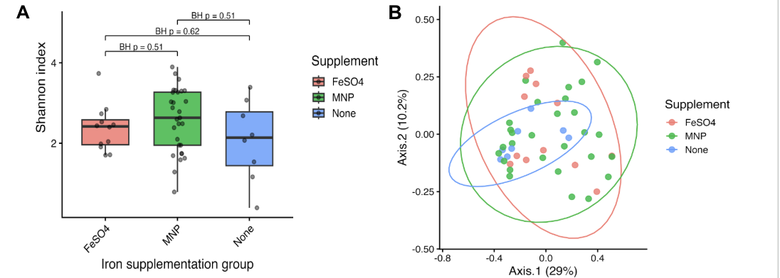
Figure 1. Microbial diversity and community composition are similar across supplementation groups. (A) Shannon diversity comparing alpha diversity across FeSO4, MNP, and no supplementation groups (27). Boxes represent interquartile range, with median indicated. Statistical significance was assessed using the Kruskal-Wallis test, with Benjamini-Hochberg correction applied for p-values. (B) Principal coordinates analysis (PCoA) based on Bray-Curtis dissimilarity showing microbial community compositions across supplementation groups (29). Each point represents a sample, and ellipses indicate 95% confidence intervals (24).

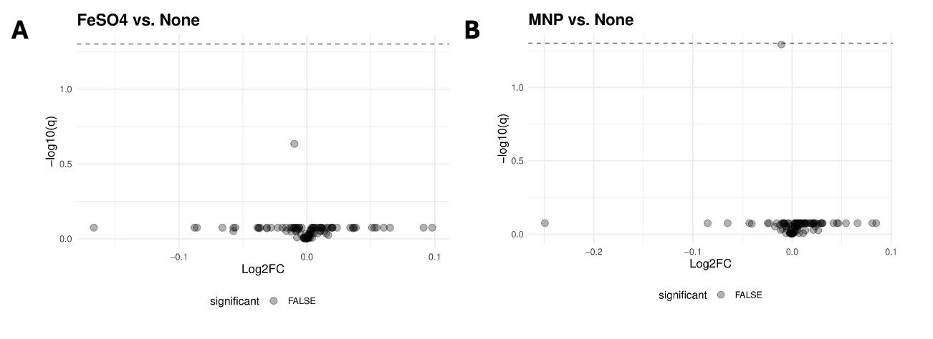
Figure 2. Indicator species analysis reveals no significant differences in the abundance between anemic infants treated with supplements (FeSO₄ and MNP) and untreated infants. The differential abundance of the microbiome composition for anemic infants was determined using Maaslin2 (32). A volcano plot was created to assess the significance of the differences between the (A) FeSO₄ or (B) MNP treatment groups compared to the control (24).
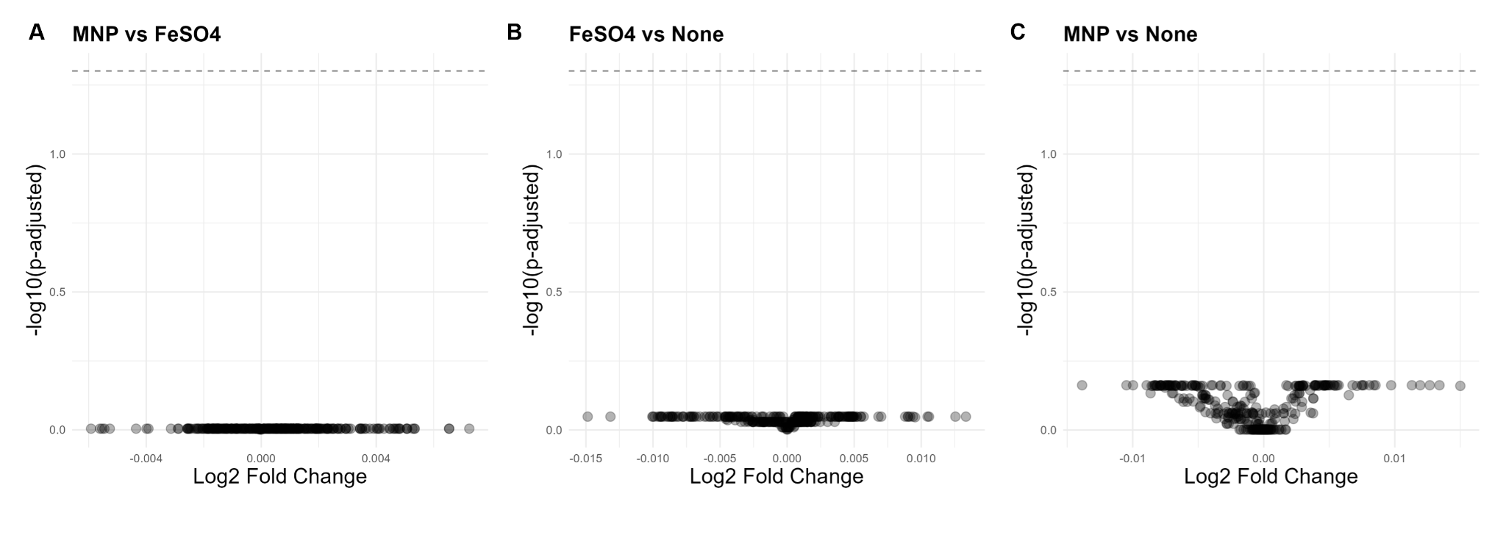Figure 3. Supplement groups have no significant differences in predicted functional metabolic capabilities of the gut microbiome. Visualization of functional analysis results depicts differences in relative abundance of predicted metabolic pathways between MNP and FeSO₄ (A), FeSO₄ and None (B), as well as MNP and None (C) treatment groups. Each point represents an individual predicted metabolic pathway. The dashed grey line indicates the threshold of significance (p-adjusted <0.05) (24).

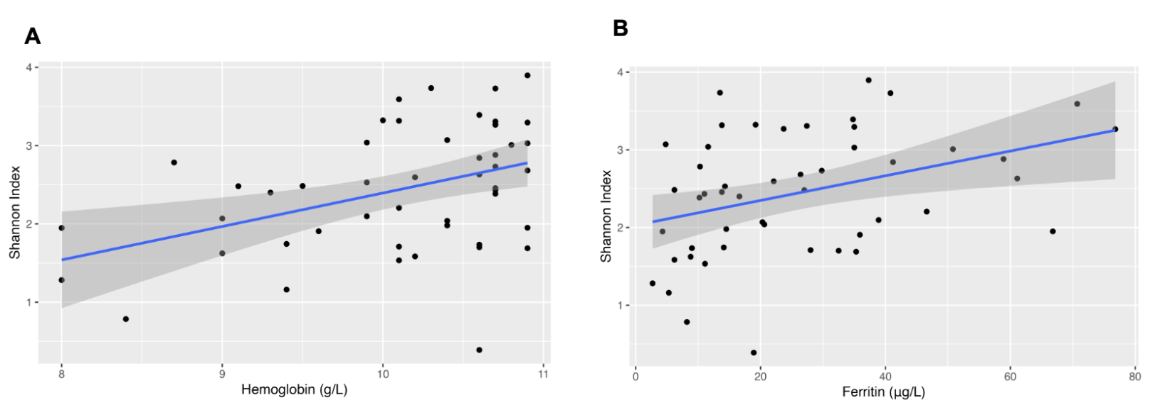
Figure 4. Spearman’s rank-order correlation tests show significant positive correlations between microbial diversity and iron biomarkers. Using the Shannon diversity index as an indicator of microbial diversity, linear regression models were fit for (A) hemoglobin or (B) ferritin levels (27). Scatter plots with regression lines were used to visualize the associations. The blue lines represent the linear regression fit, with the shaded area indicating the 95% confidence interval (37).

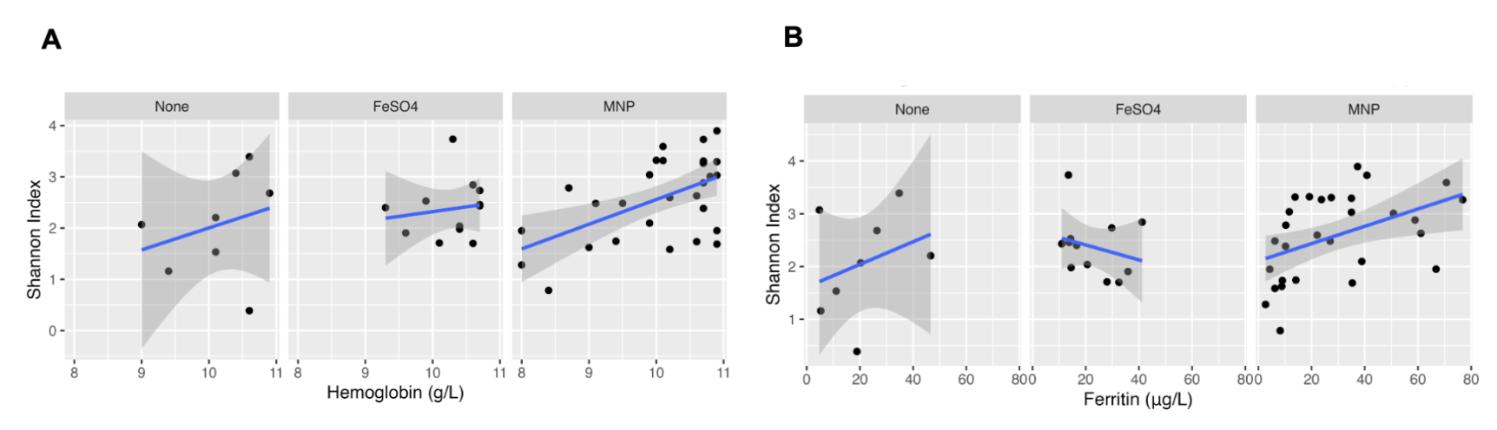

Figure 5. Linear model tests found no significant correlation between microbial diversity and iron markers between supplementation types when compared to non-supplemented infants. Changes in correlations due to different supplementation types (MNP and FeSO₄) between the Shannon diversity index and hemoglobin (A) or ferritin (B) were tested for using linear models and compared to the non-supplemented (None) group (27). The results were visualized on scatter plots with regression lines and faceted by supplementation with blue lines representing the linear regression fits, and shaded gray areas indicating the 95% confidence interval (24).

